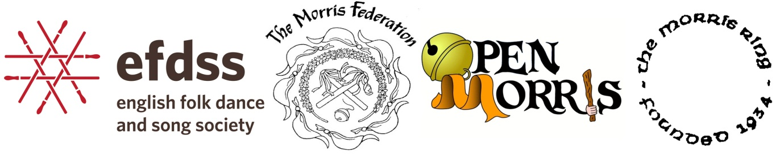

More Morris, Better Morris, in schools and beyond
Presented by the English Folk Dance and Song Society with the Joint Morris Organisation (The Morris Federation, Open Morris and The Morris Ring). Held at Cecil Sharp House, 2 Regent's Park Road, London NW1 7AY on 2 November 2014

What does good quality dance education look like? That was the theme of the More Morris, Better Morris conference, outlined by the education director of the English Folk Dance and Song Society (EFDSS), Rachel Elliott. While dance is on the national curriculum (within PE), it refers to forms wider than traditional dance and is not compulsory in many schools. School education in the 21st century has a central focus on literacy and numeracy: to demonstrate its continuing importance, dance education needs to be high quality. We need dance education that has authentic content, gives young people a sense of ownership and is positive, engaging and exciting.
Morris dancing particularly needs good dance education. Most of the delegates, myself included, at the conference were keen dancers with an interest in teaching, but lacking formal experience or training. Being enthusiastic about dance does not automatically translate into being a great teacher. But it is the best possible starting point: no teacher can learn enthusiasm for dance, or the extent of knowledge that many traditional dancers have, from a training course. As explained by conference organiser Kerry Fletcher, training and support are available through the EFDSS' Folk Educators Group and the National Dance Teachers Association, and other dance agencies and organisations.
Furthermore, research I have done recently has revealed that two thirds of morris dancers are age 50 or over whereas just 13% are under 30. This presents a major threat to the long-term future of morris dancing: morris needs young dancers in order to maintain its place in the public consciousness and in national culture. Teaching morris dancing to young people in a way that piques their interest will ensure it is passed on to future generations.
Musician, dancer and educator Liam Robinson (Mini Morris) led a magnificent warm-up that got us up dancing, but involved none of the old-fashioned standing and stretching. Each warm-up exercise acted as a prelude to dancing that introduced the themes of rhythm, spatial awareness and phrasing without any jargon. It set the tone for a day of refreshing approaches to teaching dance.
The same themes were developed further in the session with Ben Moss and Laurel Swift (Morris Offspring). They taught one or two traditional dance moves and presented them as building blocks to open up creative possibilities, not as a set of fixed instructions. After half an hour we were devising our own dance sequences, performing them and watching others’ work: authentic content, engagement and ownership in action.
In truth the conference was about much more than teaching young people, or teaching in schools: it was just about good teaching. I will be using all the insights and brilliant teaching techniques the workshop leaders gave us when I next teach my adult morris side. After 10 years I’ve forgotten what it’s like to be a beginner and perhaps lost touch with the basic point of dancing. Challenging ourselves as educators to return to that innocent and vulnerable place (a long distant place for many) is the essence of good quality dance teaching.

Jack Worth
Jack is a morris dancer and musician from Wallingford, Oxfordshire.
jack.worth@gmail.com

